
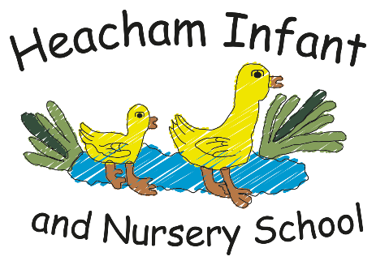

In maths, we will be learning about number and place value with a focus on numbers 6–10. We will practise subitising within 10, recalling number bonds to 10, and using addition and subtraction to compare and combine groups to find the whole, including using ten frames and part–part–whole models.

Balls skills
Introduce tennis balls, beach balls, balloons

Music & Movement session

Celebrating New Year

We will talk about the traditions for celebrating new year including learning about and exploring:

Chinese New Year
Persian New Year
Holi

This half term, we will develop our drawing skills by sketching jewellery, watches, and images of the Crown Jewels using pencil and crayons. We will design and create crowns, cloaks, and jewels using card, scissors, glue, and shiny papers in preparation for a banquet. We will also design and make a bridge, linked to the story Iggy Peck, Architect.
Music

Maths

English

.

P.S.H.E.

Reception
What your child will be learning about in Spring 1 2026…

Knowledge

Art & DT

RE

Dreams and Goals
We will learn to view ourself as a valuable individual and also think about the perspectives of others.
We will think about the things we are good at and what we would like to improve and ways we could do this.
The focus for our knowledge sessions this half term is:
Kings, Queens & Country

We will learn about the country we live in.
We will learn about important places in our country.
We will explore how buildings can look different and why.
We will learn about who our King is.
We will learn about the special roles and responsibilities of kings and queens.

Welcome to a new half term in Reception!
This half term we will be in our different phonics groups focusing on speedy recognition of our single letter sounds, blending to read simple words and writing words using the sounds we know. We will also begin to learn ‘special friends’ (two letters that make one sound). Please continue to support your child at home with learning their letter sounds. Our knowledge is going to help us understand all about the country we live in, what important landmarks we have and who our King is. We have another exciting ‘music and movement’ session with Mrs Battelley based on ‘Kings and Queens’ and more session with our PE specialist Mrs Bower!
Please let us know if you have any questions or would like more information.
Mrs Dack & Miss Moore

Lost and Found
‘Quackling’
We will learn the story and retell it together using actions. Over the half term we will innovate the story and create our own version with different characters.
We will continue to learn a wider range of songs and rhymes, clapping to the beat and rhythm. We will listen to music that is classical and instrumental (coronation music) and begin to hear and name some instruments. We will respond to music and describe our feelings. We will enjoy genres such as reggae with Bob Marley's song one love.
PE

