Reception - home learning challenges
Here are your new home learning challenges - when you do something, bring it in and show us or add a photo to Dojo ☺
Visit a farm in real life or online - can you see any young animals?  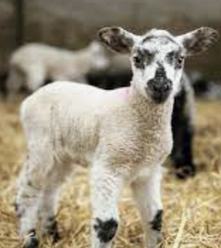 | Draw and write some facts about your favourite farm animal.  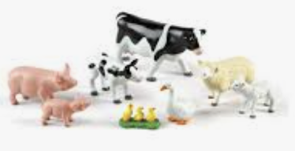 | Make a model of a plant or flower using whatever you like - label the different parts!  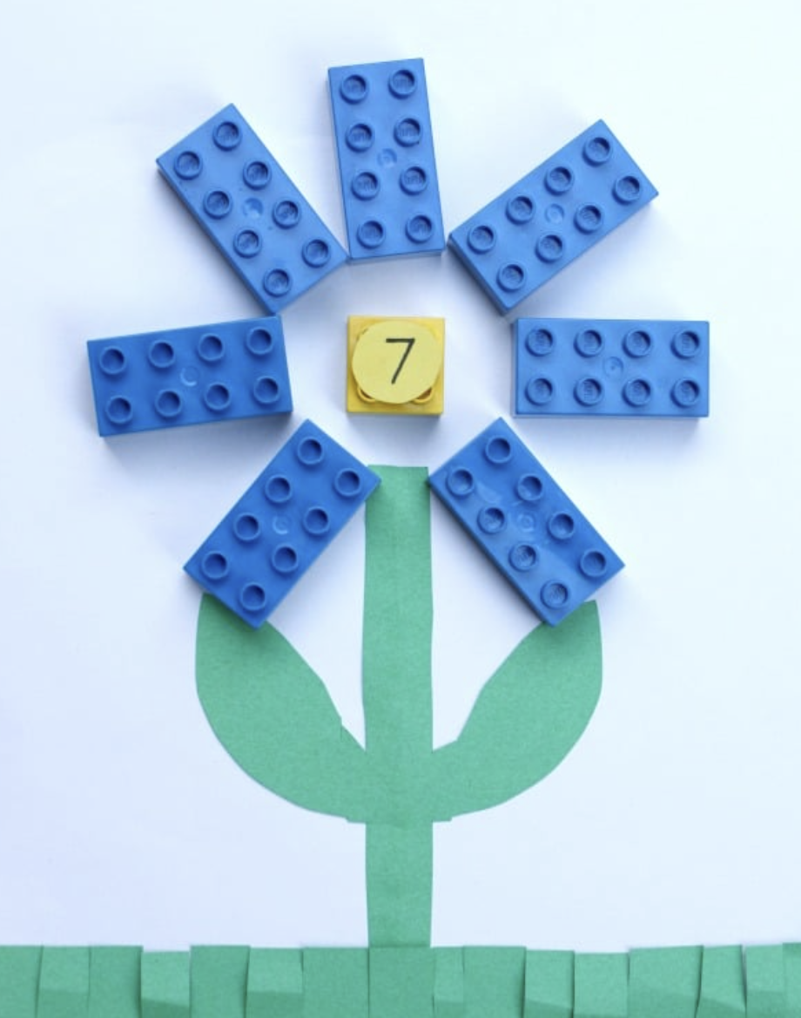 | Choose some seeds to sow and then watch carefully as they grow!  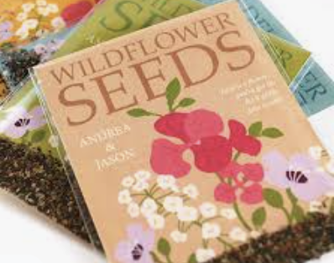
  Look in your fridge/cupboard with a grown up and see what fruits and vegetables you can find. Write a list! | Make a healthy snack using fruit! Be as creative as you like - take photo for your portfolio!  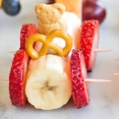 | Make a repeating pattern using toys or natural objects you have at home. Take a photo and show us!  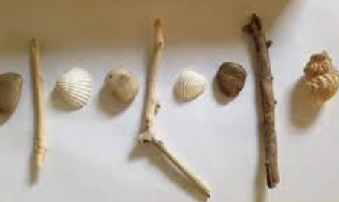 | 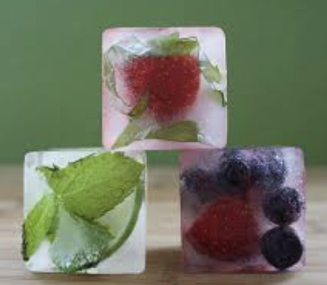  Try making some ice cubes with fruit or edible flowers in - pop them in your drink and see what happens!

