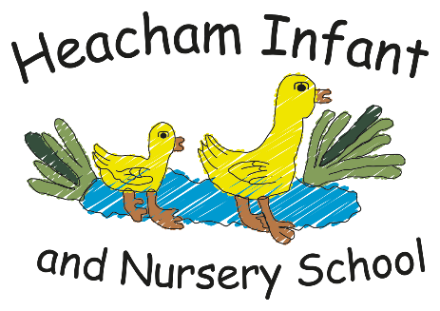
History

Stone Age to the Iron Age

I know how people lived in Britain during the Old Stone Age and Middle Stone Age.
I Know farming began in the Neolithic Age.
I know that the Bronze Age began when people
learned how to make things from Bronze.

Science

Living Things and their
Environment

I know that a food chain describes ‘who eats what’ within a habitat.

Maths

Shape
Money
Multiplication and Division

P.E.

Gymnastics
To perform gymnastic shapes and link them together.
To use shapes to create balances

English

Genre: Explanation Text
Text: Until I Met Dudley

P.S.H.C.E.

Celebrating Difference

I am starting to understand that sometimes people make assumptions about boys and girls (stereotypes).

R.E.

Hinduism

Christmas - Jesus as a Gift from God

I can explain what a “hero” is and explain why I think someone is a hero.
I know that some problems are caused by people being unkind.
I can re tell the Christmas Story

Year 2

What your child will be learning about in Autumn 2026

Computing

E-Safety

To know what online
bullying is.

To know that bullying
can make someone
feel upset, unsafe and/
or uncomfortable.

To know who to go to
for help.

Art & DT

Mechanisms and Levers

I know levers and sliders can create movement.

I know a lever moves around a pivot.

I know how to design and make a moving picture.

Geography

This will continue in Spring1.

Dear Parents and Carers,
We are excited to start the Summer term with a fresh set of topics to cover as you will see in the surrounding boxes. This learning includes knowledge of key facts to develop understanding of the world as well as practical skills. We will also have some enrichment trips and activities which we can’t wait to share with you! We strongly encourage pupils to continue to read and learn their times tables at home.
Kind regards, The Year 2 team

