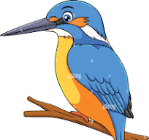
Kingfishers home learning challenges

Please choose one piece of homework to do each week and upload to Class Dojo by Friday. To upload to Dojo just go onto your child’s portfolio and upload it there. We will celebrate all completed homework in class.
Weekly homework will also include; spellings (test on Fridays) regular reading (20 mins, 5 times a week) and learning the 2, 5 and 10 time tables.
Thank you for your continued support.
Write a diary about the weather.  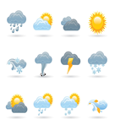 | Find out about one of the four countries of the UK and write a fact file.  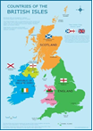 | Play a board game.  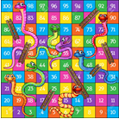 | Design your own healthy, balanced meal.  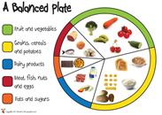
Design your own flag  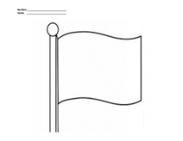 | Help to prepare a family meal.  What food did you have?  Was it from a plant or animal?   | Write a wanted poster for a fox.  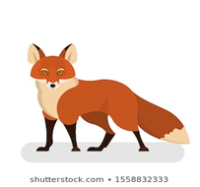 | Write all the 2-digit numbers greater than 40 using these digits.  2 4 6 6  How do you know you have them all? Prove it

