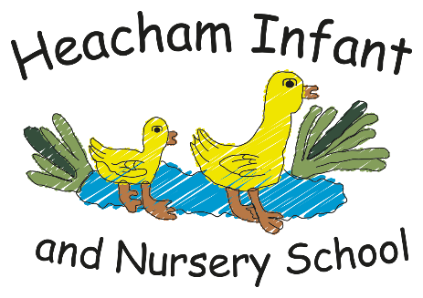
Being Me in My World
I can understand the rights and responsibilities for being a member of my class and school.
I can listen to other people and contribute my own ideas about rewards and consequences.
Spatial Sense: Maps and Globes
I know what is located on the site of my school.
I know maps show us information about a location.
PE
OAA
Understand that a diagram/map is a bird’s eye representation of the ground.

Living Things
I can classify things into living, dead and never alive.
I know that a habitat is the name given to a place where plants or animals live.

IT around us
To recognise the uses of IT
To recognise the use of information technology in school
To identify information technology beyond school
RE
What did Jesus Teach?
I can say when I have been kind to others, even when it was difficult.
I know the story of the Good Samaritan and know it means that Christians believe they should be kind to everyone.

History

The Tudors

Henry VIII

Henry VIII
’
s early life,

Henry VIII
’
s six wives,

The break from Rome,

The dissolution of the
monasteries.

Science

The Human Body

The muscular system;
The skeletal system; The
nervous system; Eyes
and ears.

Maths

Length

Area and Perimeter

Multiplication

Division

English

Newspaper Report

The Boy at the Back of
the Class

Losing & Finding Tale

.

P.S.H.E.

Celebrating Differences

Know that, sometimes, we
make assumptions based
on what people look like.
Know that sometimes
bullying is hard to spot.
Say why witnesses
sometimes join in with
bullying. Identify what is
special and unique about
me.

R.E.
-

Christianity

Christmas

Incarnation

Know what a symbol is.
Know the symbols in the
Nativity Story. Know the
symbols of a Christingle.
Know what symbols are in
a Church at Christmas.
Know what Christmas
means for Christians.

Year 2
-

What your child will be learning about in Autumn 1 2026

Dear Parents and Carers,

We are excited to have many creative outcomes from our knowledge curriculum this
term and for the children to learn lots of new and interesting facts. The children will be
learning how to think like a professional in each subject. Please continue to encourage
children to read at home and write in their diaries which book they have been reading.
We will also be continuing to learn our times tables in class so please practice these
regularly at home. We are also looking forward to delivering the Remembrance Service
and our Christmas play.

Kind Regards, The Year 4 Team

Computing

Creating Media

Audio editing

Digital recording,
creating a podcast,

editing

Creating Media

Photo editing

Changing digital
images,

retouching
images,

making a publication.

Online Bullying

in Anti
(
-
Bullying week)

.

Art & DT

Elements of Art: Space

Introduction to space
and dimensions
,
exploring space in
printing: fore ground,
middle ground,
background
,
Using
colour and detail to
show depth.

Geography

Mediterranean Europe

Key places in Europe;

Climate of
Mediterranean;

Food; Farming;

Landscapes;
Settlements

We will continue with History in Autumn 2.
Journey Tale
Zeraffa Giraffa

Newspaper Report
Traction Man is Here
Dear Parents and Carers,
We are ready for the new academic year and some great learning! This term, the children will be exploring in our curriculum and discover lots of exciting new knowledge and produce some wonderful, creative work. Please encourage your child to read at home and learn their weekly spellings.
Thank you, Miss Cornwell
Visual Art
I understand how Matisse made his cut-outs.
I know that Matisse used organic shapes and complementary colours in his cut-outs.
-Place Value
-Add and Subtract
-Shape

