Reception Home Learning Challenges – Autumn 2
Here are your home learning challenges for this half term. Have a go at as many as you can and add a photo to your portfolio on ClassDojo! ☺
Make a Diva Lamp at home? It can be made out of anything you choose.  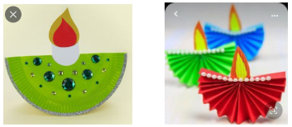 | Tell the story of The 3 Little Pigs. Maybe you can draw a story map too?  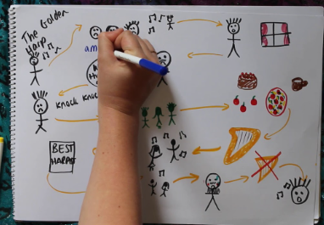 | Create a firework picture using chalk, pens and crayons.  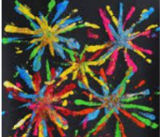 | Create a finger puppet. Maybe you can use it in a puppet show…  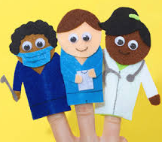
Can you make numbers 1-5 with objects around your home?  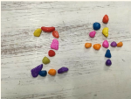 | Can you make a musical instrument?  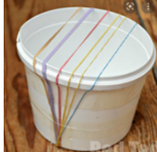 | Continue to practice writing your name! You have done a great job so far!  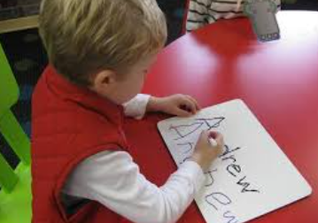 | Go outside and observe the weather.  
