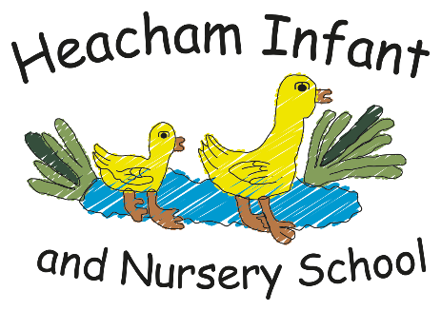
The UK
-To know that the UK is a Union of four Countries -To recognise England as the country we live in
History

The Tudors

Henry VIII

Henry VIII
’
s early life,

Henry VIII
’
s six wives,

The break from Rome,

The dissolution of the
monasteries.

Science

The Human Body

The muscular system;
The skeletal system; The
nervous system; Eyes
and ears.

Maths

Length

Area and Perimeter

Multiplication

Division

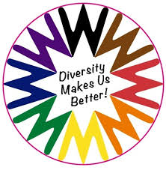

English

Newspaper Report

The Boy at the Back of
the Class

Losing & Finding Tale

.

P.S.H.E.

Celebrating Differences

Know that, sometimes, we
make assumptions based
on what people look like.
Know that sometimes
bullying is hard to spot.
Say why witnesses
sometimes join in with
bullying. Identify what is
special and unique about
me.

R.E.
-

Christianity

Christmas

Incarnation

Know what a symbol is.
Know the symbols in the
Nativity Story. Know the
symbols of a Christingle.
Know what symbols are in
a Church at Christmas.
Know what Christmas
means for Christians.

Year 1
-

What your child will be learning about in Spring 1 2025

Dear Parents and Carers,

We are excited to have many creative outcomes from our knowledge curriculum this
term and for the children to learn lots of new and interesting facts. The children will be
learning how to think like a professional in each subject. Please continue to encourage
children to read at home and write in their diaries which book they have been reading.
We will also be continuing to learn our times tables in class so please practice these
regularly at home. We are also looking forward to delivering the Remembrance Service
and our Christmas play.

Kind Regards, The Year 4 Team

Computing

Creating Media

Audio editing

Digital recording,
creating a podcast,

editing

Creating Media

Photo editing

Changing digital
images,

retouching
images,

making a publication.

Online Bullying

in Anti
(
-
Bullying week)

.

Art & DT

Elements of Art: Space

Introduction to space
and dimensions
,
exploring space in
printing: fore ground,
middle ground,
background
,
Using
colour and detail to
show depth.

Geography

Mediterranean Europe

Key places in Europe;

Climate of
Mediterranean;

Food; Farming;

Landscapes;
Settlements

RE
Who is God to Jews?
-Know what a promise is and trust.
-To know the importance of Moses
-To understand that the 10 commandments are rules that Jews believe God wanted them to follow

PE Fundamentals
-I can explore balance, stability and landing safely -I can move at different speeds

-Addition and Subtraction -Place value within 50 -Length and Height - Mass and Volume

Seasons and weather -Describing the four seasons -Types of clouds -Gathering information about the weather
Dear Parents and Carers,
We are ready for a brilliant start to the year! This term, the children will dive into our curriculum and discover lots of exciting new knowledge and produce some wonderful, creative work. They will be learning to think like a real geographer and scientist as they explore the world around them! Please encourage your child to read at home and learn their weekly spellings.
Thank you, Miss Hardingham, Mrs Varley and Miss Minns

Food Technology DT
-I know what food comes from plants and animals -I know how to chop safely -I can create a healthy menu
Dream and Goals
-I can set a goal and work out how to achieve it
-I can explain how it felt when I succeeded in a new challenge and how I celebrated it
Tale of acceptance
Mixed By Aree Chung
We will continue with History in Spring term 2.
Grouping data
-I can describe and group objects using labels and properties
-I can compare two groups
-I can answer questions about groups

