
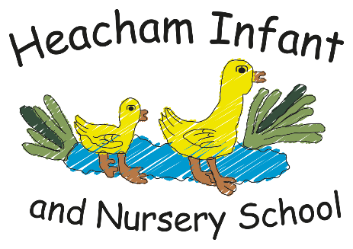

Celebrating difference
-I understand that everyone is different but the same in some ways
- I can tell you why I think my home is special
- I can tell you how to be a kind friend

-I understand 1 more
-I understand 1 less
-I know my number bonds to 5
-I can recognise numbers 6 and 7
-I can use a tens frame

This half term, we will be creating our own Diwali lamps with clay, creating a painting inspired by Kandinsky and making a gift.

Cumulative story
‘The three little pigs’
We will learn the story and retell it together using actions. Over the half term we will innovate the story and create our own version with different characters.

Gymnastics
-I can copy and create shapes with my body
-I can copy and create short sequences by linking actions together

Christmas
-The Christmas story
-Giving and saying thank you
-The Shepherds
-The Wise Men

Music

Maths

English

.

P.S.H.C.E.

Reception
What your child will be learning about in Autumn 2 2026…

Knowledge

Art & DT

RE
The focus for our knowledge sessions this half term is:
Light and Celebrations
- Why is light special to Hindus?
- Who was Guy Fawkes?
- Why do we have day and night?
-What is weather?
-Why do the seasons change?
-How do people celebrate Christmas?

Welcome to Autumn 2! This update provides an overview of the weeks ahead, as our pupils dive into the knowledge rich curriculum. We can’t wait to see the children gain new insights and showcase their talents through creative projects. Keep up the great homework challenges, we look forward to seeing them! In our knowledge lessons we will learn all celebrations and different types of celebrations along with the weather.
Thank you for your continued support.
Please let us know if you have any questions or would like more information.
Miss Hardingham, Miss Bateson, Miss Minns and Mrs Chadburn
My stories
-I can listen and respond to different styles of music
-I can sing along to nursery rhymes and action songs
-I can perform songs I have learnt
PE

