Reception Home Learning Challenges - Spring 2
Here are your home learning challenges for this half term. Have a go at as many as you can and add a photo to your portfolio on ClassDojo…you have until the end of March! ☺
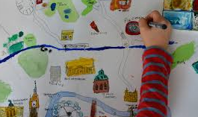  Take a trip by bike, car or foot – take some photos of your journey or draw a map! | Draw and write some facts about a mode of transport you like.  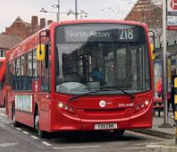 | Make up a story with a grown up about the adventures of a hot air balloon!   | Make a model of a plane, train, bus – or another way of travelling – bring it in and show us!  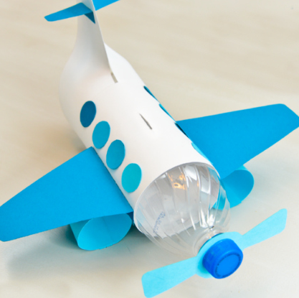
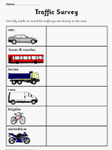  Do a traffic survey from your house/garden. How many cars/buses/vans can you see in 5 mins? | Make a healthy snack to give you some energy if you were going on a journey ☺. Take photos or bring in and share!   | Talk about a trip you had once on a boat/train/bus. Where did you go, did you need a ticket, how long did the journey take?  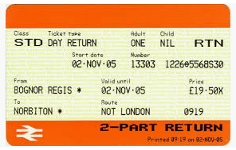 | Ask a grown up at home about your car/bike. How does it work? What parts does it have? Tell us what you found out!  