Knowledge Organiser
EYFS Autumn 2 - Light & Celebrations
Why is light special to Hindus? Who was Guy Fawkes?
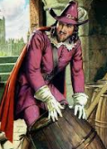
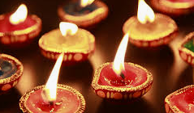

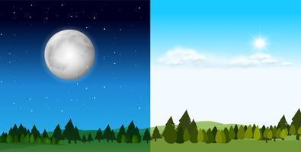
Why do we have day and night? What is weather?
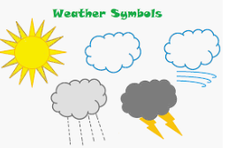


How do the seasons change? How do people celebrate Christmas?
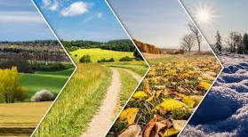
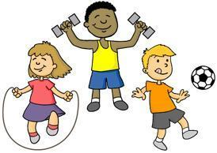

Key vocabulary
Diwali - a Hindu celebration of light
diva lamp – a small, clay lamp lit at Diwali
Guy Fawkes – the leader of the Gunpowder Plot
Gunpowder Plot – the plan to blow up the Houses of Parliament
Nocturnal – animals that are mainly active at night
Orbit – a repeating path that one object in space takes around another.
forecast – predicting what the weather will do
meteorologist – someone who studies the weather
seasons – 4 parts of the year
celebration - people remember a special event or story
traditions - things people have done for many years

Recapping on learning
Observation checkpoints to guide parents, carers and practitioners
Personal, Social and Emotional Development
Self-Regulation
Do they show fascination, high levels of involvement and interest with learning about light, celebration?
Are they able to focus and persist in their learning by adding detail to recording, conversation and play?
Managing Self
Is the child co-operative and flexible so they can manage the balance of adult directed and child chosen play?
Can they find classroom resources like scissors, pencils, tape, aprons, counters, dice, books and use them independently to support their learning?
Build Relationships
Are they increasingly socially skilled and able to wait for others as they role play, build or play games?
Can they describe their needs and articulate feelings with teachers, their family and other children?

Communication and Language
Listening and Attention
Can children listen to adults and each other talking about Diwali, family celebrations and retelling stories like that of Rama and Sita?
Can children show they have been listening by using key vocabulary about light, celebration and worship?
Understanding
Do children show their understanding in adult directed sessions for light, celebration as well as in their self-chosen play?
Speaking
Do children show they understand learning through applying focus key vocab in their own play - e.g. Diwali, worship, Rama, Sita, Diva Lamp?
Do children speak clearly in sentences - adding detail to what they say with increasing complexity? e.g.- I can retell the story of Rama and Sita (then retells a version with characters, events and conclusion)

Physical Development Moving and Handling

Gross Motor Skills
Can children choose to move in a range of ways, moving freely and with confidence making changes to body shape, position and pace of movement such as slithering, shuffling, rolling, crawling, walking, running, jumping, skipping, sliding and hopping
Fine Motor Skills
Can children show a preference for a dominant hand?
• Begin to use anticlockwise movement and retrace vertical lines when mark making e.g. in Diwali patterns
• Begin to form recognisable letters independently
• Uses a pencil and holds it effectively to form recognisable letters in RWI, most of which are correctly formed

Health and Care
Do children show an understanding of the need for safety when tackling new challenges e.g.- using scissors to cut a range of papers?
Can they consider and manage some risks themselves or by giving a verbal warning to others?

Reading
Can children describe main story settings from Rama and Sita and T4W texts, they know events and characters in increasing detail and can discuss?
Do children know that information can be retrieved from books in our book corner, computers and mobile digital devices?
Can they begin to read some high frequency words, and to use developing knowledge of letters and sounds to read simple phonically decodable words and simple sentences?
Do they engage with books and other reading materials at an increasingly deeper level, sometimes drawing on their phonic knowledge to decode words, and their knowledge of language structure, subject knowledge and illustrations to interpret the text?

Writing
Can they start to apply handwriting and phonic skills to label and write short sentences around light and celebrations in supported groups?
Can children enjoy creating writing in their play to communicate meaning for an increasingly wide range of purposes, such as making Diwali greeting cards, lists, invitations and creating their own stories and books with images and sometimes with words?
Do children give meaning to the marks they make as they draw, write, paint and type using a keyboard or touch-screen technology?
Can children start to break the flow of speech into words, to hear and say the initial sound in words and may start to segment the sounds in words and blend them together when attempting to compose and record writing?
Mathematics
Counting
Do children enjoy reciting numbers from 0 to 10 (and beyond) and back from 10 to 0 in play and altogether?
Are children increasingly confident at putting numerals in order 0 to 10 (ordinality) and making estimates of the number in a group?
Cardinality
Can children use loose parts and concrete resources to subitise numbers to four and maybe five. Counting out up to 10 objects from a larger group?
Do children match the numerals with a group of items to show how many there are (up to 10)
Composition
When using concrete resources, can children add one and subtracts one with numbers to 10?
Do they begin to explore and work out mathematical problems, using signs and strategies of their own choice, including (when appropriate) standard numerals, tallies and “+” or “- “?
Spatial Awareness
Do they use spatial language, including following and giving directions, using relative terms and describing what they see from different viewpoints?
Shape
When making rangoli patterns can children describe shapes and patterns (e.g. heart-shaped and hand-shaped leaves), as well as mathematical terms to describe shapes? Do they enjoy composing and decomposing shapes, learning which shapes combine to make other shapes?
Pattern
Can children begin to see and talk about repeating patterns when they create rangolis? Can they continue a pattern consistently?
Measure
Can children consider a sequence through day to night and use words linked to time - Can they look at a calendar for names of days and months in a year identifying seasons?
People, Culture and Communities /Past Present
Do children talk about family customs and routines linked to celebration?
Can they talk about past and present celebrations in their own life and in the lives of family members? Do they show that experiences differ depending on different families?
Natural World
• Can they looks closely at the weather, talk about differences in seasons, patterns and changes that take place in nature over the Autumn term - using conkers and apples from the garden
Creating with materials
Can children sing and remember simple songs and dances from their repertoire? Do they enjoy making music in a range of ways - making weather sounds like rain, wind, hail or thunder for example?
Can they choose and use pencil, felts, powder paint, charcoal, loose parts and papers to make images?
Being imaginative and expressive
Can they create representations of both imaginary and real-life ideas, events, people and objects through illustrating their learning in Light and Celebration?
Can they play cooperatively as part of a group to create, develop and act out imaginary ideas or narratives? For example, creating monster stories influenced by Rama and Sita or retelling of Guy Fawkes?
Technology
• Can they complete a simple program on electronic devices like talking tins or bee bots?
Can they use ICT hardware to interact with age appropriate computer software?
• Can create content such as a video recording about the weather or stories

