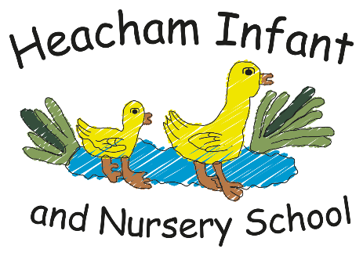

History

The Tudors

Henry VIII

Henry VIII
’
s early life,

Henry VIII
’
s six wives,

The break from Rome,

The dissolution of the
monasteries.

Science

The Human Body

The muscular system;
The skeletal system; The
nervous system; Eyes
and ears.

Maths

Length

Area and Perimeter

Multiplication

Division

English

Newspaper Report

The Boy at the Back of
the Class

Losing & Finding Tale

.

P.S.H.E.

Celebrating Differences

Know that, sometimes, we
make assumptions based
on what people look like.
Know that sometimes
bullying is hard to spot.
Say why witnesses
sometimes join in with
bullying. Identify what is
special and unique about
me.

R.E.
-

Christianity

Christmas

Incarnation

Know what a symbol is.
Know the symbols in the
Nativity Story. Know the
symbols of a Christingle.
Know what symbols are in
a Church at Christmas.
Know Christmas
.

Year 2
-

What your child will be learning about in Spring 2 2026

,

Computing

Creating Media

Audio editing

Digital recording,
creating a podcast,

editing

Creating Media

Photo editing

Changing digital
images,

retouching
images,

making a publication.

Online Bullying

in Anti
(
-
Bullying week)

.

Art & DT

Elements of Art: Space

Introduction to space
and dimensions
,
exploring space in
printing: fore ground,
middle ground,
background
,
Using
colour and detail to
show depth.

Geography

Mediterranean Europe

Key places in Europe;

Climate of
Mediterranean;

Food; Farming;

Landscapes;
Settlements

Cross curricular
Using IT skills across the curriculum to enhance our learning.
-Fractions - wholes, quarters, thirds
-Time - half past, quarter to, quarter past, digital times
Matter and Materials Atoms
Solids, liquids and gases
The Romans.
Growth of the Roman Empire.
Roman invasions in Britain.
Instructions
How to look after a dragon

The Owl who was afraid of the dark
Dream and Goals
-I can think about a realistic goal and set out how to achieve it
-I can persevere when I find things difficult
-I can explain ways I worked creatively
Dear Parents and Carers,
Here’s an overview of our learning topics for the Spring 2 half term. Please encourage your child to read at home, learn their weekly spellings and add home learning challenges to Dojo.
Thank you, Miss Bennett, Mrs Tilbrook, Miss Johnson & Mrs Francis

Geography
Continues in Summer 1
Still life and form
Studying artists’ work
Eg Georgia O’Keefe
Giorgio Morandi
Drawing flowers.
PE
Striking & fielding
Batting, fielding and bowling
Team games & skills practise

RE
Easter resurrection

Bible story of Easter.
Know what the story means to Christians.

