Goldfinches Home Learning Challenges – Autumn 2
Please choose one piece of homework to do each week and upload to Class Dojo by Friday. To upload to Dojo just go onto your child’s portfolio and upload it there. We will celebrate all completed homework in class.
Thank you for your continued support!😊
Make a Diva Lamp at home? It can be made out of anything you choose.  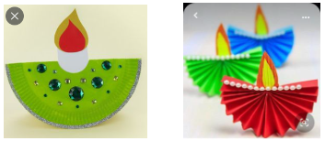 | Tell the story of The 3 Little Pigs. Maybe you can draw a story map too?  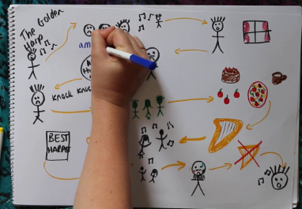 | Create a firework picture using chalk, pens and crayons.  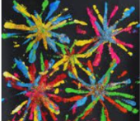 | Create a finger puppet. Maybe you can use it in a puppet show…  
Can you make numbers 1-5 with objects around your home?  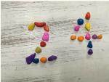 | Can you make a musical instrument?  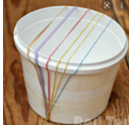 | Continue to practice writing your name! You have done a great job so far!  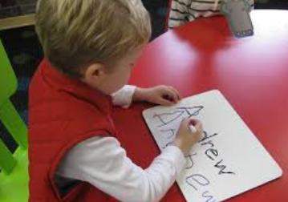 | Go outside and observe the weather.  

