Kingfisher’s Home Learning Challenges – Autumn Term 1 2026
We love seeing and sharing all the wonderful activities completed at home!
When you complete a piece of work, you can either bring it into school or post it online via Class Dojo.

English  Make some pancakes like Tom Cat. Write a list of your ingredients  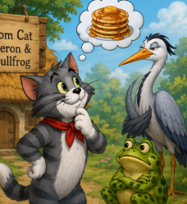 | Maths  Practise writing your numbers - Be creative! There are lots of fun ways to do this!  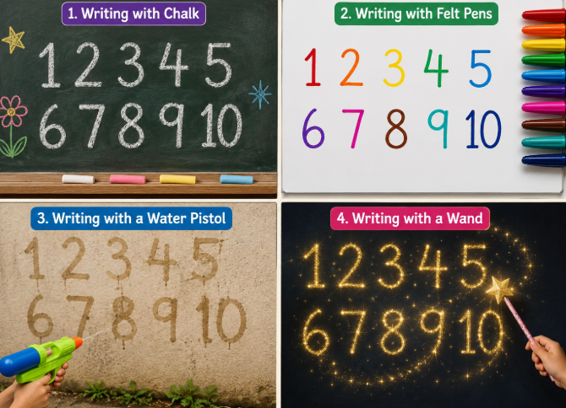 | Science  Make a person using natural objects. How many body parts can you name?  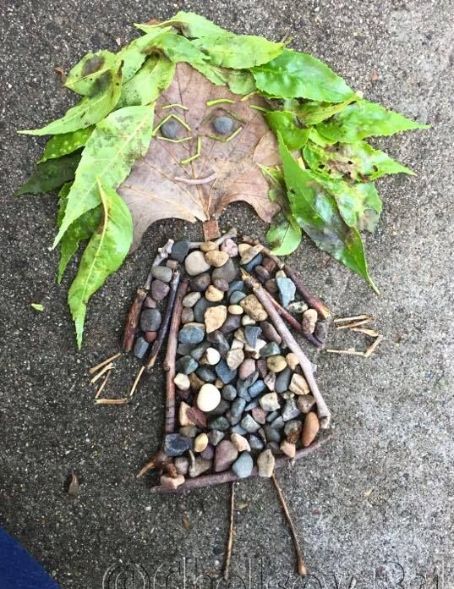 | Remember to read regularly!  Don’t forget to get an adult to write in your reading record so that you can earn your reading stamps.  
Geography  Draw and label a map showing your journey to school  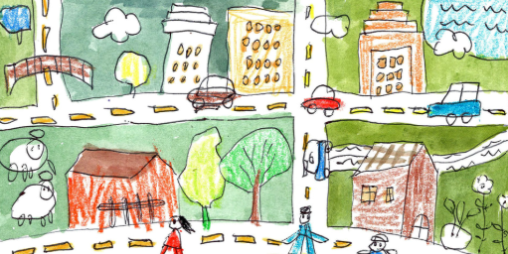 | RE  Look outside and see how many different plants and trees you can spot. Do you know their names?  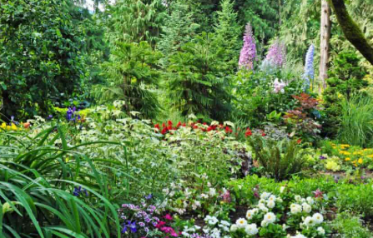 | Art | Life Skills  Be proud by making your own toast! Practise spreading butter or jam onto your toast to make it delicious!  