Reception - Home Learning Challenges!
Here are your home learning challenges for this half term. Have a go at as many as you can and add a photo to your portfolio on ClassDojo!
Talk about somewhere you have been to in England. Can you find it on a map?  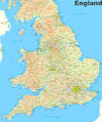 | Can you add a photo on Dojo of somewhere you have visited in England?  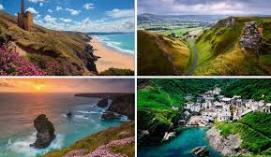 |   Find out about Big Ben, the London Eye or Buckingham Palace. Draw a picture of the building and write a fact about it.  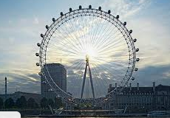 | Make a crown fit for a King or Queen! Add a photo to your portfolio.  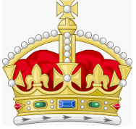
Cut out 5 paper squares or collect 5 pebbles. How many different patterns of 5 can you make with them? Draw what you find out.   | Bake a cake you think the King would enjoy! Take a photo & share with your family or bring in and share!   | Go for a walk somewhere and draw a map to show where you go. Add some pictures of things you pass on the way.  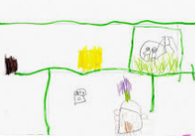 | Visit your local Library and see if you can find a story about a King/Queen or one set in London!  