Reception Home Learning Challenges – Autumn 1
Here are your home learning challenges for this half term. Have a go at as many as you can and add a photo to your portfolio on ClassDojo! ☺
Go on a walk and see what types of houses you can see. Detached, semi-detached, terraced, bungalow, flats… or any others?   | Tell the story of Finding a Friend to someone at home? Maybe you could draw it too…  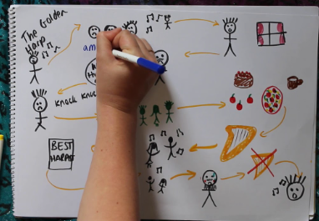 | Make a model of your house using junk modelling? Bring it in to show us!  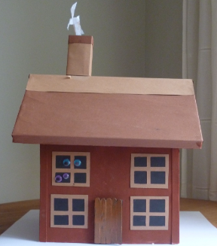 | Draw who lives in your house or who is in your family?  
Draw around yourself and label your body parts?  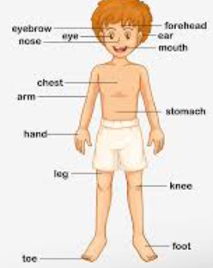 | Make yourself a healthy snack. Maybe it could be for snack time one day?   | Practice writing your name!  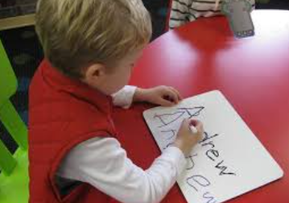 | What different feelings do you have? Why do you have these feelings?  