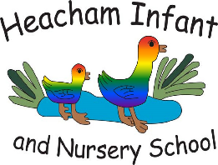
Heacham Infant and Nursery School

School Road, Heacham, PE31 7DQ
01485 570357

Dear Parents/Carers,

RSE Curriculum

As a part of your child’s education, we promote personal wellbeing and
development through a comprehensive Personal, Social, Health and Economic
(PSHE) education programme. PSHE education is the curriculum subject that
gives children the knowledge, understanding, attitudes and practical skills to
live safe, healthy, productive lives and meet their full potential.
The teaching of Relationships Education and Health Education (which includes
learning about the changing adolescent body and puberty) is a legal
requirement for all schools and parents will not be able to withdraw their child
from any aspect of Relationships Education as it is important that all children
receive this programme, covering topics such as friendships and how to stay
safe. Sex Education is not statutory in primary schools but schools are
expected to provide a programme of age appropriate sex education. Parents
have the right to request to withdraw their child from any aspects of Sex
Education other than those that are part of the science curriculum.
We follow Jigsaw RSE, which links to the National Guidance for RSE. For further
information on National Guidance go to:

https://www.gov.uk/government/publications/relationships-education-
relationships-and-sex-education-rse-and-health-education

We are interested to hear your views and welcome any queries or comments.
Please contact the office via email.
Yours sincerely



