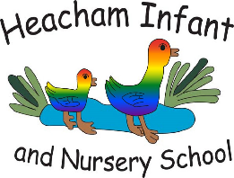
Heacham Infant and Nursery School

School Road, Heacham, PE31 7DQ
01485 570357
office@heachaminfant.co.uk
www.heachaminfant.co.uk

Key Dates for Summer Term

Dear Families,

Please find below some key dates for your diary for the final term of the school year.

Event | Heacham Infant School
SATS week | 11/5/26 – 14/5/26
Y2 Roman Experience | 15/5/26 Friday
Y1 Trip to Sandringham | 14/5/26 Thursday  9.00am – 3.00pm
Zoolab visit to school | 8/6/26 Monday  8.30am -12.00
KS1 Dance Festival @ Corn Exchange | 16/6/26 Tuesday  12.00 – 3.00pm
(TBC) Trust Sports event @HJS with Tracy Bower
Apprenticeship Day – Little City visit to school | 19/6/26 Friday
Life Skills workshop | 18/06/26 Thursday
Area Sports @ Smithdon Y2 – Y6 | 2/7/26 Thursday  4.30pm – 6.30pm
Y1 & Y2 KS1 Sports Festival @ HJS | 3/7/26 Friday  9.00am – 2.30pm
WNAT Community Music Festival Week @Springwood | 6/7/26 – 9/7/26  Monday - Thursday
Music Workshop @Springwood | Vocal Celebration Yr2/5&6  8/7/26 Wednesday  5.00pm – 7.30pm
KS1 Active Kids festival @Lynnsport | 6/7/26 Monday  10.00am – 11.30am
Sports Day | 2/7/26 Thursday PM
Year 2 Leavers Assembly | 9/7/26 Thursday PM TBC
Move Up Stay Up | Last week of term TBC
New Starters Meeting | TBC

